T15

The 180 toggle switch on the front panel of the PHASE SHIFTER influences the phase of the signal and reverse the signal of sin(x) because the sin(ut) becomes sin(ut+pi) and also equals -sin(ut). Actually, there is a little error between real number and measurement because we use the COAPSE control. Besides toggle isn’t accurate because we need adjust result by using the COAPSE and FINE control.

T17

Coarse and fine controls give very accurate result but it is time consuming while toggle switch is very fast but doesn't give accurate result, so the combination of the two is better.The first step is make the two signal is equal to each other. Then use 180 toggle to make them different of 180 degree phase.

T18

Signal A

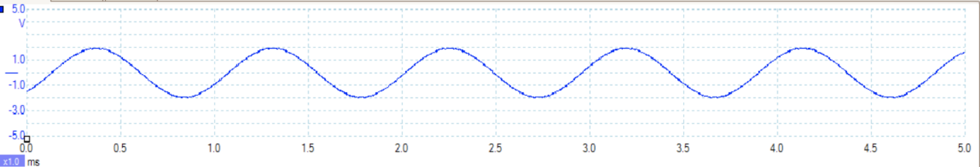

Signal B

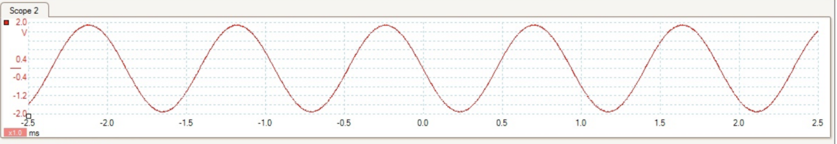

T20

Same scale

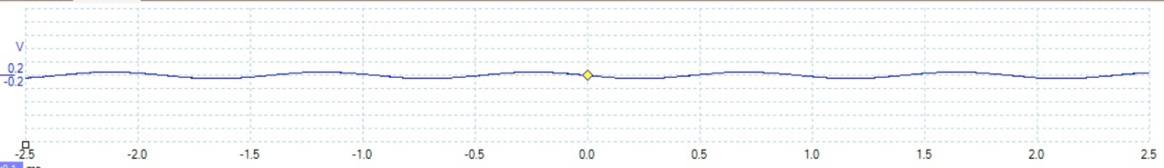

Zoomed vision

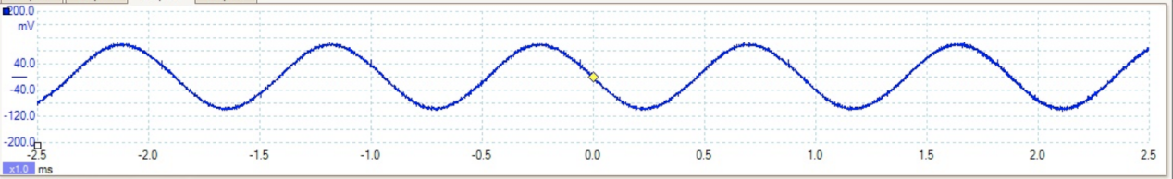

Same scale picture can compare with the input sinusoid obviously. Zoomed vision can appear the accurate number of amplitude and frequency. There are two factors affecting the amplitude of ADDER output. The first one is that there are some error in operations and we can’t create 2 signals which have 180 phrase difference accurately. The second one is that there is always noise in the nature. Therefore we can’t avoid it. The frequency of our minimum output is 1000 HZ.

T21

15\*2=30 mv

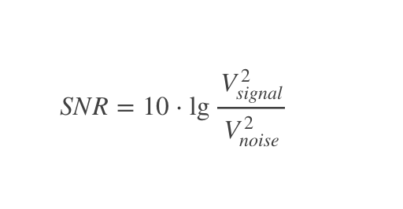

SNR=10\*lg(16/0.08^2)=33.9794

T22

4\*2=8 volts

It seems that the ADDER number is twice as much as the number of 4 volts peak to peak. It indicates ideally that the range of output of ADDER module is from 0-8 volts.[30mv-8v]

Q1

The reason why noise can’t be cancelled is that there is always noise existing in the nature. It doesn’t depond on the frequency.

Q2

I have no idea. Maybe the noise level is constant because it just be influenced by surroundings instead of the frequency of source.